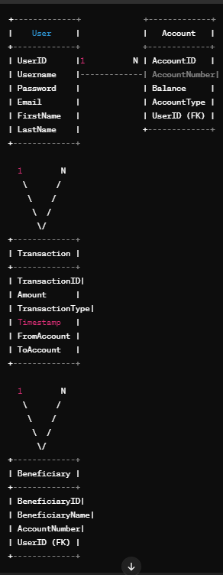

**1 N**

Transaction

TransactionID

Amount

TransactionType

TimeStamp

FromAccount

ToAccount

User

Account

UserID

Username

Password

Email

FirstName

LastName

AccountID

AccountNumber

Balance

AccountType

UserID(FK)

**1**

**Login Process Level 1 Login Process Level 1 Login Process Level 2:**

**Level 0 Level 0 : Level 0**

**Level 0 Level 1 Level 1**

**Level 2**